

**World Population (1970-2022) Analysis using SQL**

1. Created Database **world_population** by the help of **creating schema** and importing the csv into that database. Table name is createdas **world_population** and now checking the data.

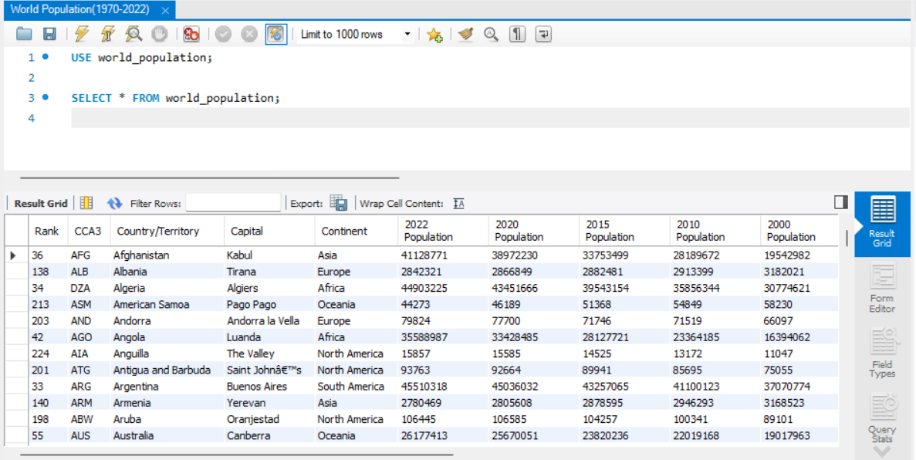

1. Total rows in this table **world_population** are **234** rows.

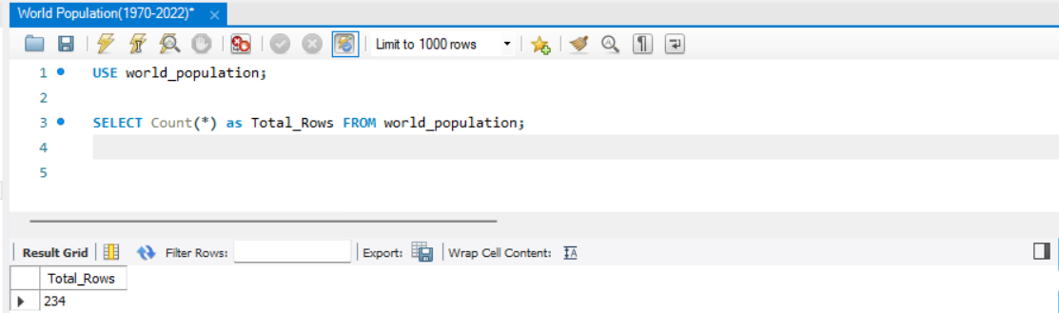

**NOW STARTING THE DATA ANALYSIS BY WRITING QUERIES**

1. **Total countries by Continent:**

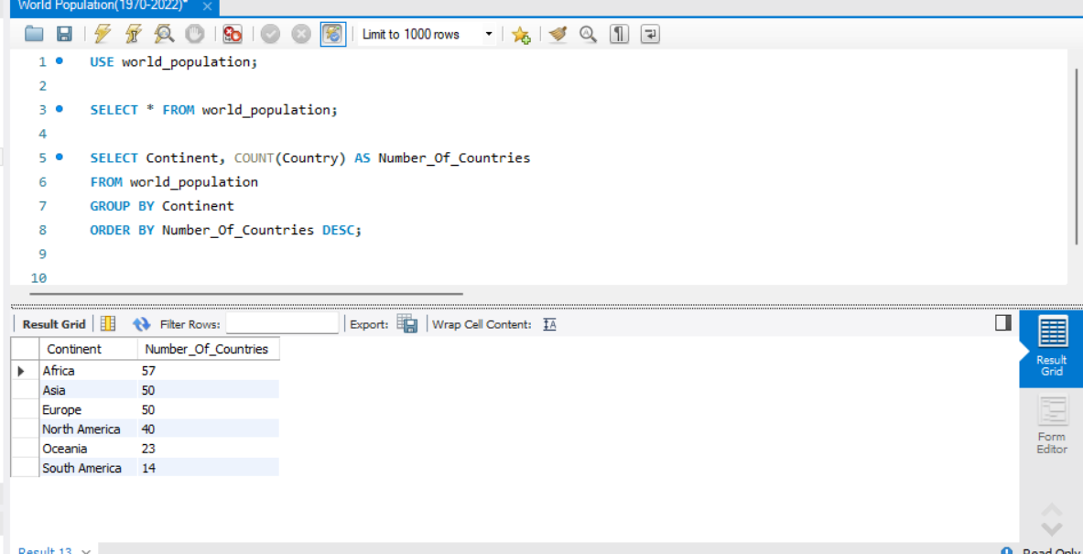

1. **Highest 2022 population:**

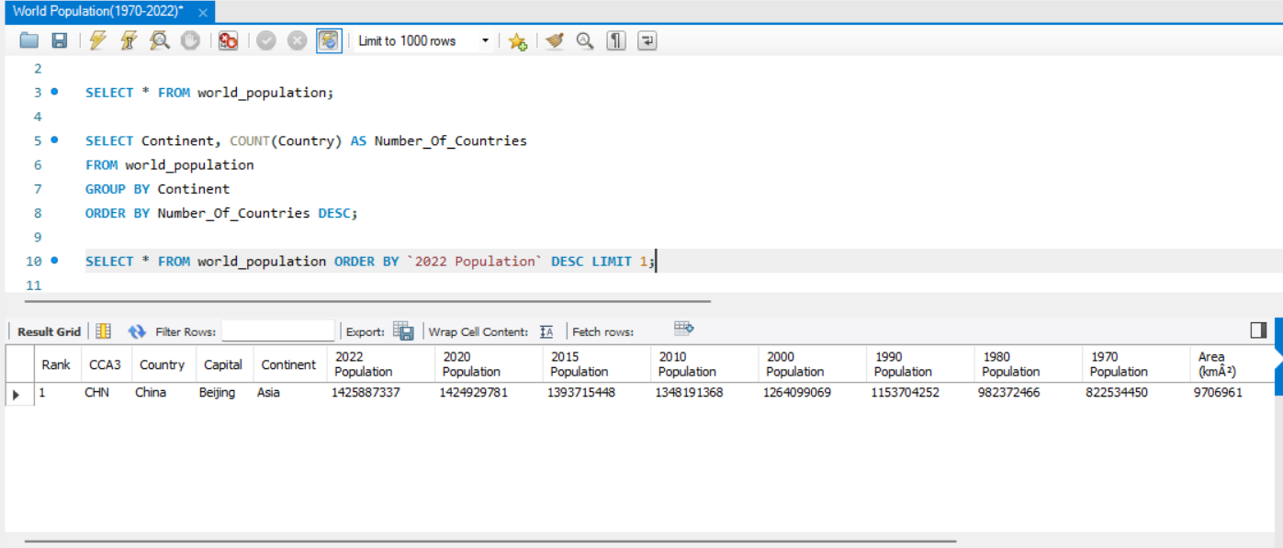

1. **Highest Populated Countries in Asia:**

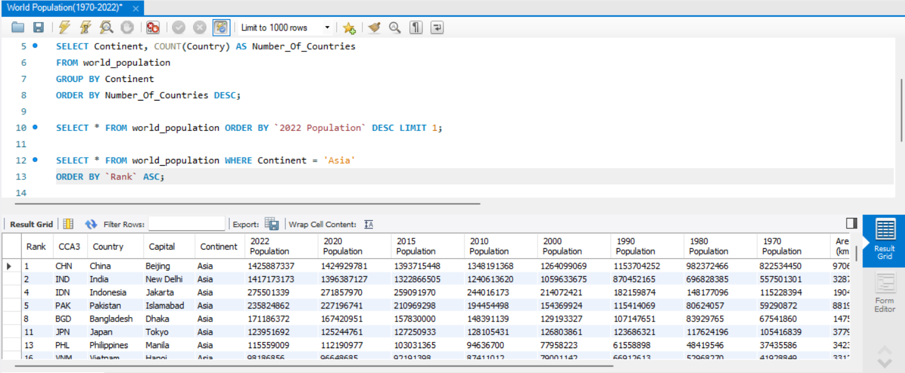

1. **Top 5 Average population in 2022:**

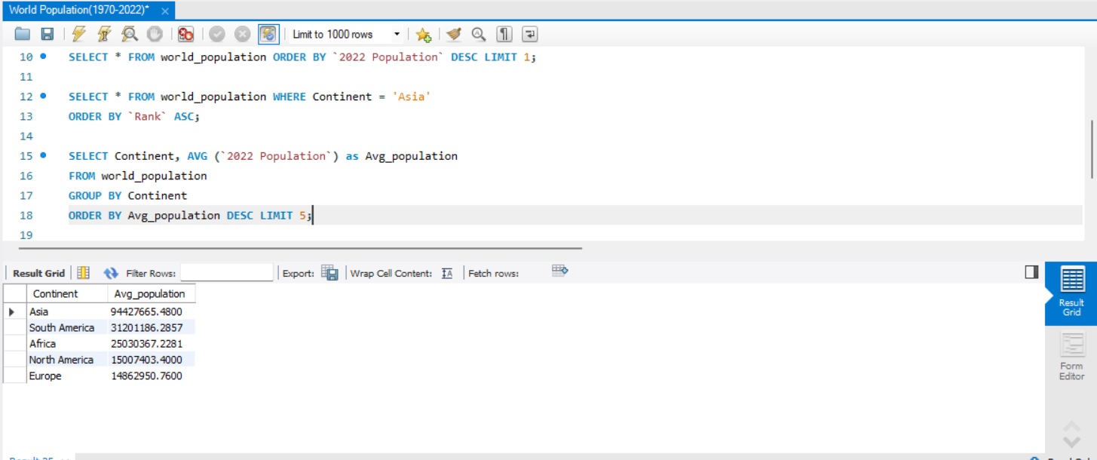

1. **Top 5 Countries by Density per km:**

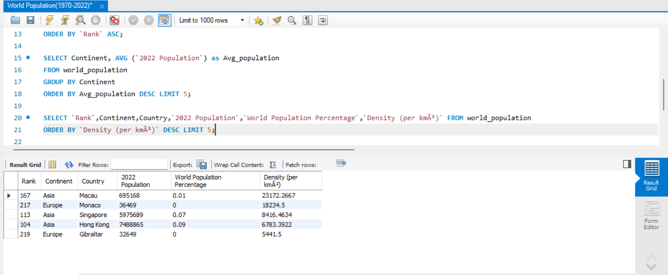

1. **Top Growth Rate:**

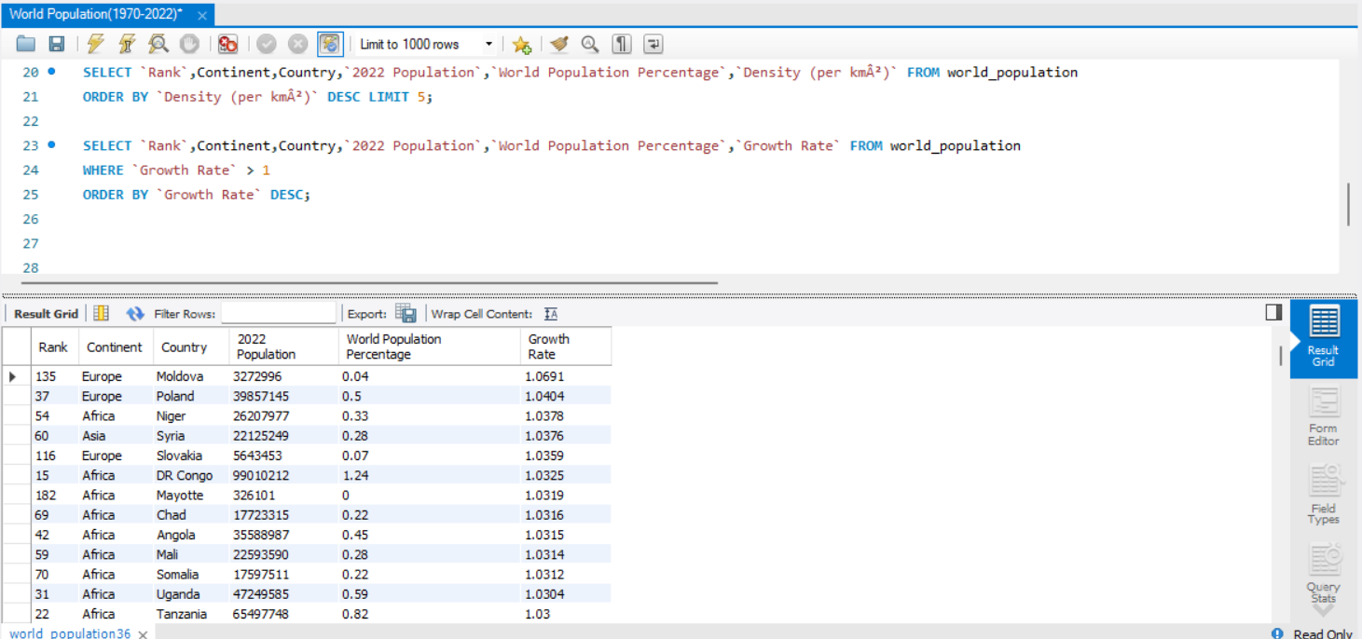

1. **Continent & Country by High Population:**

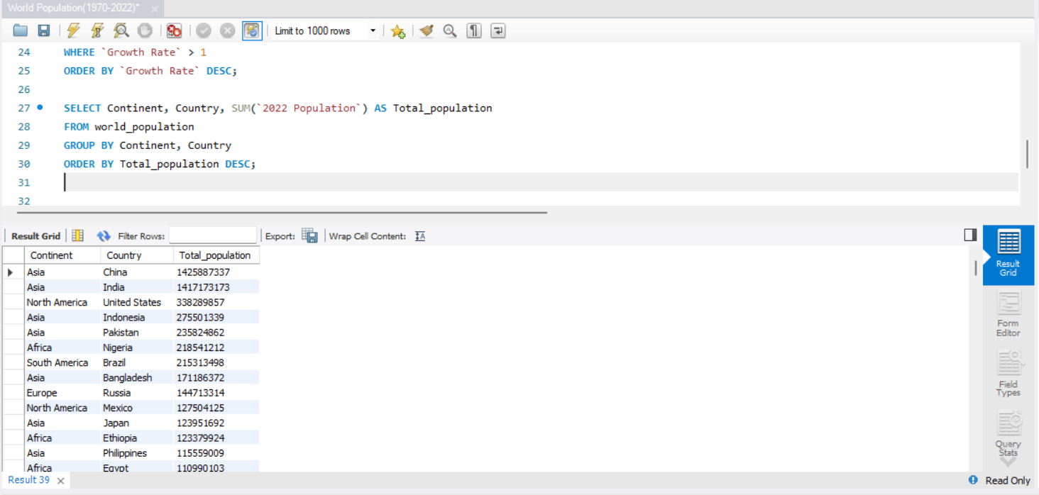

1. **Countries, Population by lowest Area:**

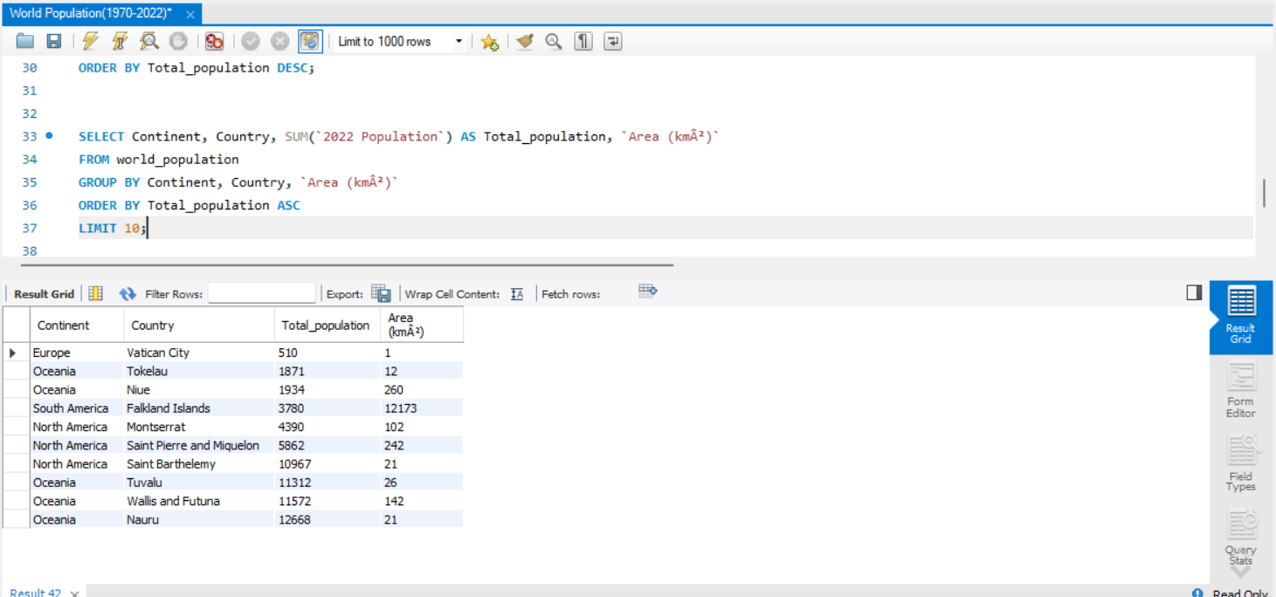

1. **Countries’ Population Greater than 50M and Growth Rate lesser than 1:**

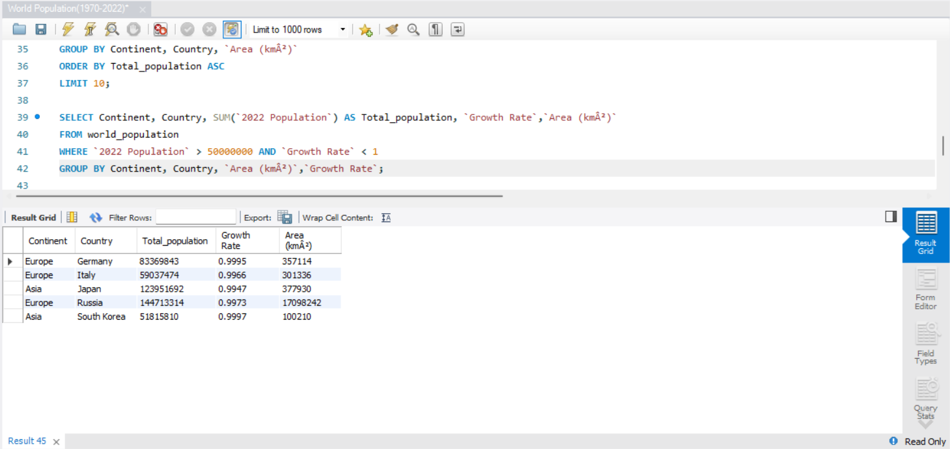

1. **Countries with Highest Growth Rate:**

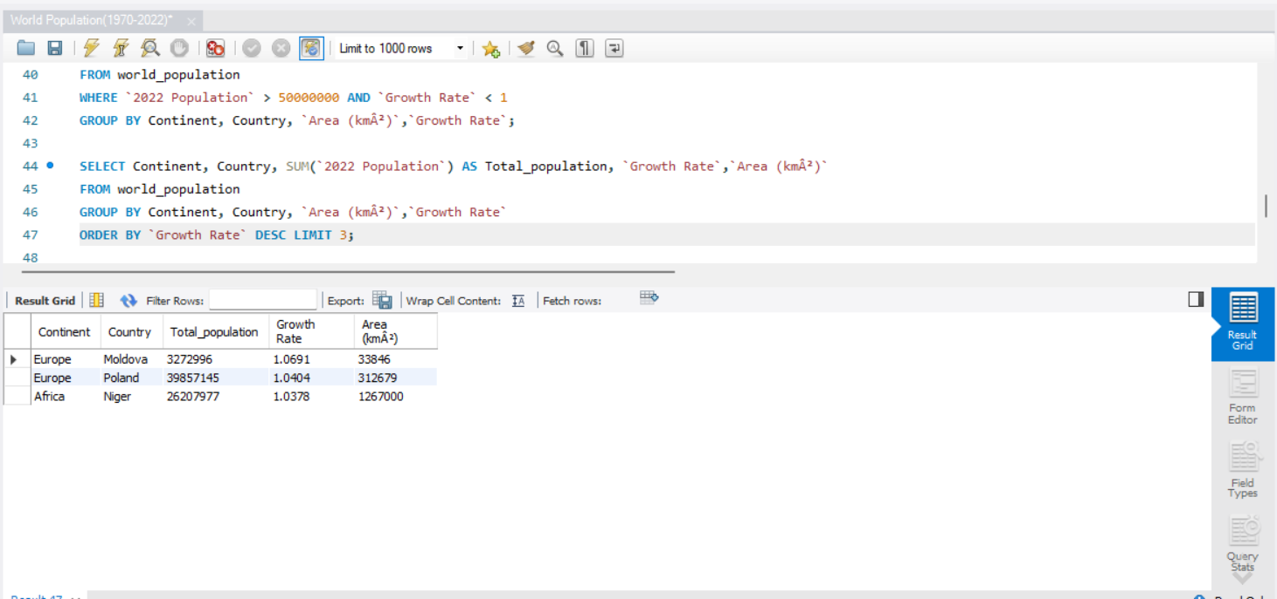

1. **Top 10 Countries’ 2022 Population lesser than 2020 Population:**

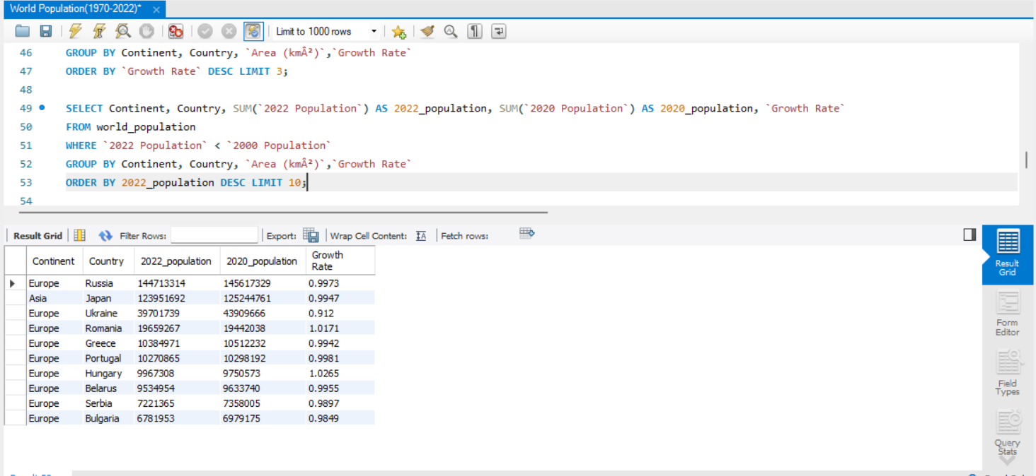

1. **Largest decrease in population from 1970 to 2022:**

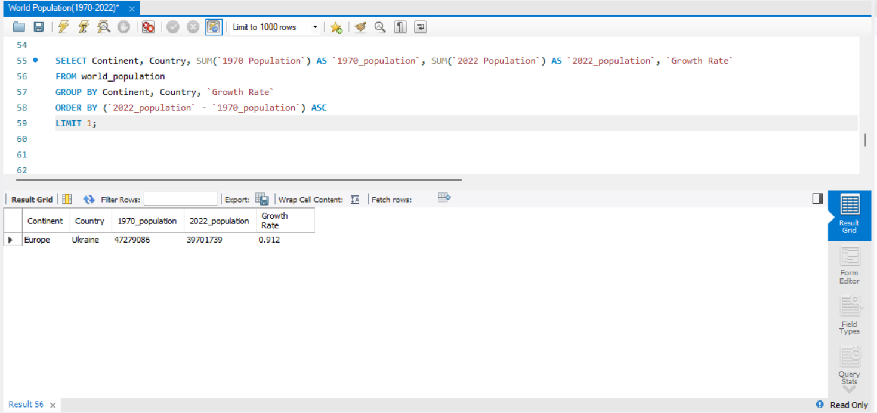

1. **Highest population percentage of the world population in 2022:**

**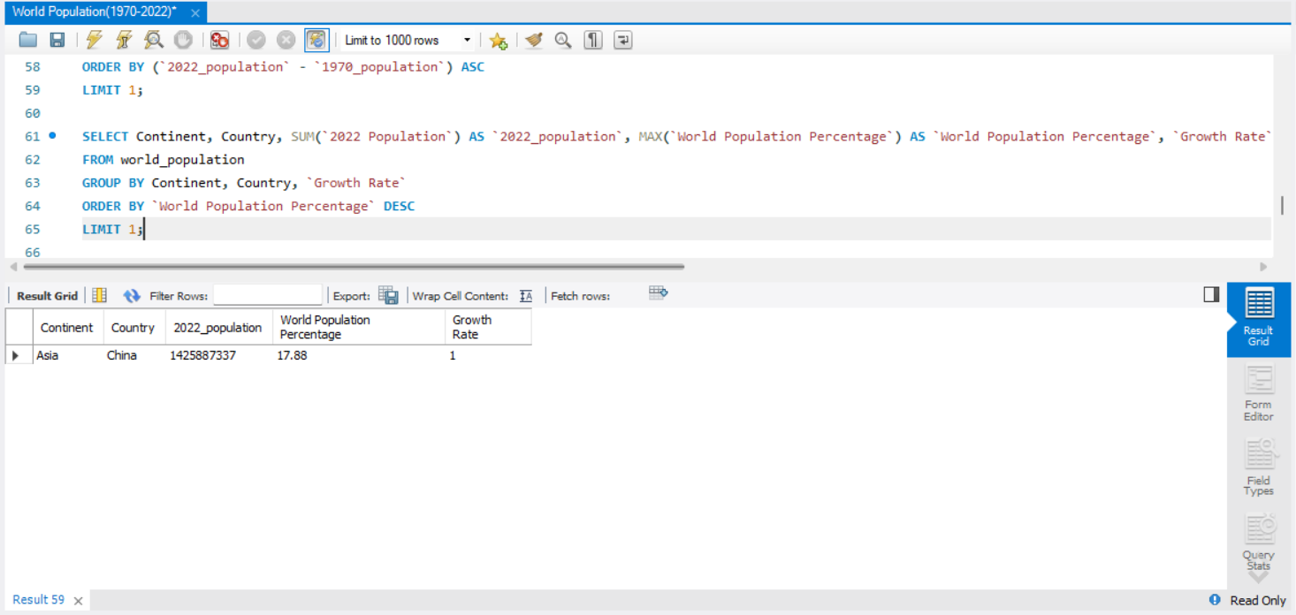  
  
  
THANK YOU !!**